October 3, 2025
Dirac’s Equation and the Birth of Antimatter
In 1928, a young British physicist named Paul Dirac set out to solve a great puzzle in physics: how to make the new quantum theory of the atom play nicely with Einstein’s theory of special relativity. Quantum mechanics described the weird behavior of electrons and other particles at the atomic scale, while relativity governed high speeds and energies. The two theories were individually successful but philosophically at odds. Dirac’s quest was nothing short of unification – a single equation that could describe an electron moving close to the speed of light, obeying both quantum mechanics and relativity.
Dirac’s effort culminated in a beautiful mathematical formula now called the Dirac equation[1][2]. This equation did more than anyone expected. It naturally incorporated the electron’s spin (an intrinsic “twist” of the particle) and correctly predicted many of the electron’s properties. But it also presented Dirac with a startling implication: every solution for a normal electron, with positive energy, was mirrored by another solution with negative energy[2]. In classical physics, negative energy made no sense, it was like finding a bank account with a negative balance that could go infinitely lower. An electron, according to Dirac’s relativistic wave equation, could exist in states of negative energy. This was deeply troubling. If these solutions were real, an electron could drop down to ever lower energy levels without limit, emitting light endlessly. Simply put, an electron should not be able to switch into a positive-charge state in our world.
“Such a transition would appear experimentally as the electron suddenly changing its charge from –e to +e, a phenomenon which has not been observed,” Dirac noted[3].
Dirac refused to throw away these strange solutions – one “cannot do this on the quantum theory,” he insisted[4]. Instead, he tried to make sense of them. With a mix of boldness and logic, he proposed a radical idea: perhaps what we think of as empty space – the vacuum – is not truly empty at all. Maybe it is filled with an infinite ocean of electrons occupying all the negative-energy states. In this picture, all the “weird” negative-energy slots are filled up, so real electrons (which have positive energy) have no available lower state to fall into[5]. This idea is known as the Dirac sea, and Dirac imagined it as a sort of cosmic ocean underlying everything. Just as an ocean’s surface represents the lowest level water can occupy, the sea of negative-energy electrons represented a baseline – filled to the brim. A real electron would ride above this sea, unable to dive below the surface.
But what if one of those negative-energy slots in the sea were empty? Dirac realized that a hole in this endless sea would behave in a curious way. It would act like a particle with the opposite properties of an electron[6]. He first thought this mysterious hole might correspond to the proton (the only positively charged particle known at the time). However, fellow physicists like Robert Oppenheimer quickly pointed out problems. If the hole were a proton, an electron falling into it should annihilate with the proton, releasing a flash of energy, which clearly doesn’t happen in ordinary atoms[7]. Moreover, as mathematician Hermann Weyl noted, the hole should have the same mass as an electron, while a proton is about 2000 times heavier[8]. Dirac conceded these points. The proton idea was wrong. He had to go further.

The Dirac Sea: A Cosmic Ocean of Negative Energy
Dirac revisited his “sea” concept and made a bold leap of imagination. If a hole in the negative-energy sea wasn’t a proton, perhaps it was an entirely new particle – the electron’s mirror image. In 1931, he published a paper proposing that the mysterious hole would be an “anti-electron”[9][10]. This antiparticle would have the same mass as an electron, but a positive electric charge. In effect, it would be a kind of “mirror electron”, now known as a positron. Dirac wrote that a hole in the sea “would be a new kind of particle, unknown to experimental physics, having the same mass and opposite charge to an electron. We may call such a particle an anti-electron”[11][12]. It was a breathtaking prediction: a form of matter no one had ever seen. Dirac doubted we’d find such things in nature, they might quickly destroy themselves by “recombining” with electrons, but he suggested they could perhaps be created in high-energy collisions, for example when “two hard γ-rays” (high-energy photons) collide[13].
To visualize Dirac’s idea, imagine the vacuum as a vast ocean of negative-energy electrons, stretching infinitely in an unseen dimension. Normally, this ocean is calm and uniform, completely filled, so we don’t notice it. But if you pluck an electron out of this ocean, you leave behind a ripple, a “bubble” in the sea of energy. That bubble behaves like a particle itself, as if nature abhors a vacuum so much that even a missing electron manifests as a tangible thing. “It is like a bubble in water. As water sinks, the bubble rises to the top of the water level,” explains one analogy[14]. In an electric field, all the negatively charged electrons in the sea would drift one way, and the empty bubble – missing an electron – would move the opposite way, carrying a positive charge[14]. The bubble in the cosmic ocean is the positron. Dirac’s strange mental picture suggested that space was far from empty, it was a kind of endless, bubbling cosmic ocean, and antimatter was the foam rising to its surface.
Critics found the Dirac sea concept hard to swallow. It implied an infinite charge and energy permeating space (one had to imagine the “vacuum” had infinite positive charge to cancel the infinite negative sea)[15][16]. Still, Dirac’s insight was compelling because it offered a way out of the negative-energy conundrum and it predicted a new particle. In a famous milestone for theoretical physics, Dirac had used pure thought to foresee the existence of antimatter. As one modern historian put it, “Dirac’s prediction of the existence of antimatter is a triumph of rational thought, following the mathematical representation of reality to an inevitable conclusion that cannot be ignored, no matter how wild and initially unimaginable it is”[17].

The Positron: Matter’s Mirror Emerges
In the early 1930s, a few physicists took Dirac’s prediction seriously and went hunting for this mysterious anti-electron. It wasn’t long before the prediction became reality. In 1932, Carl David Anderson, a 26-year-old American physicist, was photographing the tracks of cosmic rays in a cloud chamber (a device that reveals particle paths as misty streaks). To his astonishment, Anderson saw a track left by “something positively charged, and with the same mass as an electron”[18]. This was exactly the kind of evidence an anti-electron would produce. After careful checking, Anderson concluded he was indeed seeing positrons created by energetic particles from space smashing into his detector. He had found Dirac’s antiparticle. Anderson famously dubbed the particle the positron, (“positive electron”), and published his results in Science in 1932[19]. A year later, another team in Europe (Patrick Blackett and Giuseppe Occhialini) confirmed the discovery by capturing positron tracks from radioactive decays[20]. The anti-electron was no longer speculation, it was real.
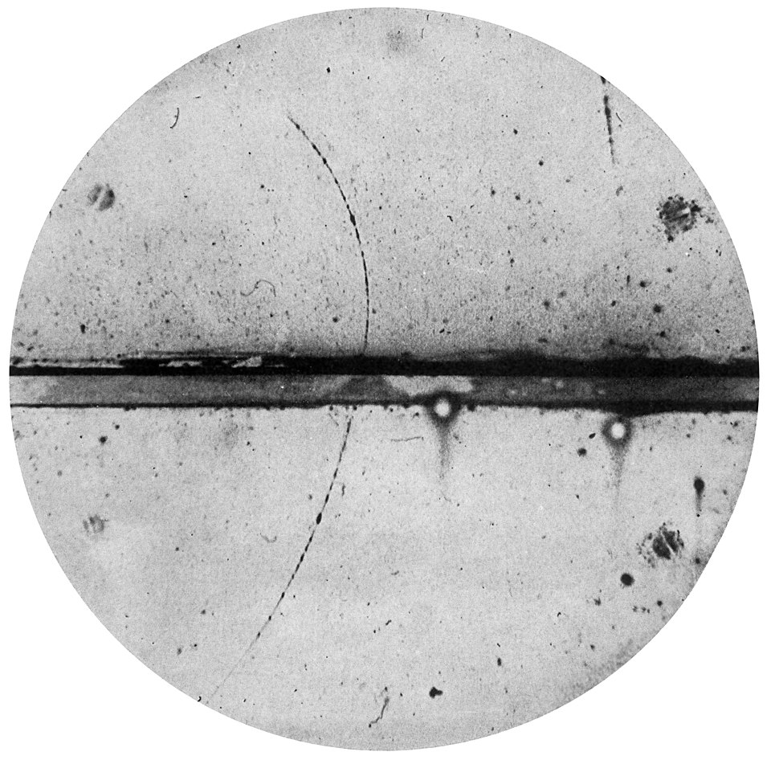
Cloud chamber photograph of the first positron ever observed, taken by Carl D. Anderson in 1932. The positron’s track (entering from below, curving upward to the left) reveals a positively charged particle with the same mass as an electron[21][22]. The image provided the first visual proof of antimatter.
Dirac’s theoretical vision had been vindicated in spectacular fashion. In 1933, Dirac received the Nobel Prize in Physics for this work (shared with Erwin Schrödinger), and Anderson would earn his Nobel Prize in 1936 for discovering the positron[23]. In his Nobel lecture, Dirac reflected on the profound symmetry suggested by his equation. “If we accept the view of complete symmetry between positive and negative electric charge... we must regard it rather as an accident that the Earth (and presumably the whole solar system) contains a preponderance of [ordinary matter],” Dirac said[24]. He went so far as to speculate that perhaps somewhere in the cosmos there might exist entire stars made of antimatter: “It is quite possible that for some of the stars it is the other way about, these stars being built up mainly of positrons and negative protons. In fact, there may be half the stars of each kind”[24]. This idea of cosmic symmetry was far ahead of its time. (Today, scientists are still investigating if any primordial antimatter chunks – like anti-helium nuclei – drift through space, but so far matter dominates our observable universe.)
The positron was just the beginning. Once physicists accepted Dirac’s insight that every particle might have a mirror-image antiparticle, the hunt was on for other examples. In antiprotons and antineutrons were created in laboratories in the 1950s (earning yet more Nobel prizes), and over time, antimatter went from a theoretical curiosity to a central part of particle physics. Quantum field theory (QFT), developed in the 1930s and 1940s by Dirac and others, recast the Dirac sea idea in a new language. In QFT, the vacuum is not literally filled with negative-energy electrons, but Dirac’s hunch of a symmetric solution was spot-on. Instead of a “sea,” QFT describes empty space as a state teeming with potential, where particles and antiparticles can be summoned into existence in pairs, and then disappear, through the energy of fields. In modern terms, an electron field permeates space, and what Dirac called a “hole” we now simply call a positron, a real particle produced when enough energy is given to the vacuum. The mathematics of QFT elegantly handles antimatter by allowing particles to have creation and annihilation operators. In fact, Richard Feynman later offered a mind-bending interpretation: one can view a positron as an electron moving backwards in time. In Feynman’s diagrams, an electron world-line that flips direction acts just like a positron in our forward time[25]. This interpretation, while visual and mathematical, underscores how deeply intertwined matter and antimatter are in quantum theory, they are two sides of the same coin, often literally trading places in equations when time is reversed.

Antimatter in the Modern Vacuum
Though physicists no longer speak of a literal “Dirac sea” filling space, the concept of vacuum energy is alive and well. The vacuum in quantum field theory is a lively developmental ground for particle–antiparticle pairs. Even in empty space, fluctuations can briefly bring a particle and its antiparticle into existence before they annihilate again. This happens so quickly and on such small scales that we can’t observe these “virtual” particles directly, but their effects can be measured (for example, in tiny shifts of electron energy levels). The vacuum energy and constant pair creation are essentially a modern echo of Dirac’s idea that the vacuum is not empty at all, but richly structured. One striking consequence of this is annihilation: whenever a particle meets its antiparticle, they can convert all their mass into energy (often high-energy photons). This is the flip side of pair creation (energy turning into matter-antimatter pairs) and is routinely seen in particle accelerators and certain radioactive decays.
Dirac’s legacy also lives on in the concept of symmetry in physics. His equation was the first hint that nature might have a built-in particle–antiparticle symmetry, now known as CPT symmetry (combining charge, parity, and time reversal symmetries). With a few exotic exceptions (like the neutral photon, which is its own antiparticle), every known fermion has an antiparticle counterpart. When matter and antimatter meet, they annihilate into pure energy; likewise, pure energy can crystallize into matter and antimatter in tandem. It’s an almost poetic balance: nature seems to require both or neither. Why, then, is our universe today made almost entirely of matter, with hardly any primordial antimatter to be found? That remains one of the great cosmic mysteries. Physicists suspect a tiny asymmetry in particle interactions (violations of symmetry like CP violation) tipped the balance in the early universe. But the fact that we can even pose the question is thanks to Dirac’s insight that antimatter should exist in the first place. His theoretical discovery paved the way for asking such deep questions about the cosmos.
From the 1930s onward, scientists learned to create and study antimatter in the lab. They found it behaves just like normal matter in almost every respect, aside from having opposite charges. Antimatter isn’t some “evil twin” with fanciful sci-fi properties, it’s just regular matter’s mirror image. An antihydrogen atom, for example, is composed of a positron (positive electron) orbiting an antiproton (negative proton). It has the same mass and, according to theory, the same spectral lines and internal structure as a normal hydrogen atom. The guiding principle from Einstein’s General Relativity is that gravity should couple to energy and mass the same way, regardless of what kind of particle it is. In other words, a kilogram of antimatter should feel the same weight as a kilogram of matter in Earth’s gravity. But until recently, this was never directly tested. As one CERN physicist quipped, in physics “you don’t really know something until you observe it”[26]. This brings us to a cutting-edge quest that ties back to Dirac’s legacy in a surprising way: Does antimatter fall just like matter?

Falling Antimatter: Dirac’s Legacy Meets Einstein’s Gravity
Ever since Dirac’s time, physicists have assumed that antimatter, being just regular matter with opposite charge, responds to gravity like ordinary matter, it falls “down.” After all, as Einstein described, gravity isn’t a charge-dependent force; it’s the curvature of spacetime caused by energy and mass. Still, this assumption had never been experimentally verified with actual neutral antimatter atoms. The reason is simple: producing and gathering enough antimatter to test gravity is extraordinarily difficult. Antimatter instantly annihilates upon touching normal matter, so you can’t just drop anti-apples from a tree and watch them fall! The experiments require ultra-high vacuum, strong magnetic traps, and super-cold temperatures to hold onto antimatter long enough to see how gravity acts on it.
In recent years, a small group of experiments at CERN (often playfully called the Antimatter Factory) have been tackling this challenge. One of these is the AEgIS experiment (Antimatter Experiment: gravity, Interferometry, Spectroscopy)[27]. Housed at CERN’s Antiproton Decelerator, AEgIS was designed specifically to answer the question: does an antihydrogen atom drop with the same acceleration g as a hydrogen atom? In other words, does antimatter obey the Weak Equivalence Principle of gravity, which says that all objects fall the same way in a gravitational field, regardless of their composition? Theory says yes, antimatter should fall down with acceleration g ≈ 9.81 m/s², but nature had never been asked directly.
Building on decades of advances, the AEgIS team and others developed techniques to produce cold antihydrogen atoms and measure their behavior under gravity. Antihydrogen is made by combining antiprotons (supplied by a special ring called ELENA that tames high-speed antiprotons into slow ones) with positrons from a radioactive source[28][29]. The trick is to do this in a trap and then form a beam of neutral antihydrogen. AEgIS uses a clever apparatus called a Moiré deflectometer – essentially a device with multiple gratings – to detect tiny deflections of an antihydrogen beam due to gravity[30]. The concept is reminiscent of Galileo’s classic experiments with dropping objects, but here it’s more like firing a horizontal cannon of anti-atoms and seeing if the Earth’s pull makes the beam sag downward by a tiny amount during its flight. Measuring that sag is incredibly challenging; even a small stray electric or magnetic field could throw off the result, so everything must be carefully controlled.
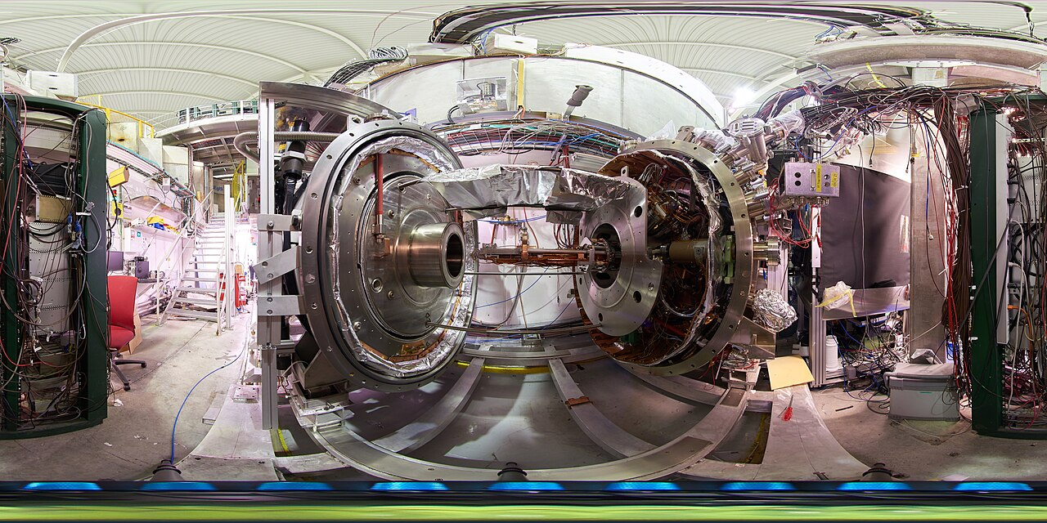
360 degrees view of the AEgIS experimental zone
Progress has been steady. By 2018, AEgIS demonstrated the first pulsed production of antihydrogen, creating anti-atoms in timed bunches so the moment of their formation was known with microsecond precision[31].
“This is the first time that pulsed formation of antihydrogen has been established... Knowing the moment of antihydrogen formation is a powerful tool,” explained Michael Doser, AEgIS spokesperson[32].
Knowing when each anti-atom is born allows researchers to synchronize lasers and other manipulations, and to start the “stopwatch” for measuring free-fall. The ultimate goal is to measure the drop of antihydrogen to around 1% precision or better[33][34]. Achieving this would either confirm Einstein’s expectation for antimatter or, just maybe, reveal a tiny anomaly. Even the slightest difference in how antimatter falls – say, 1% slower or faster than normal matter – would shock the physics world, hinting at new forces or physics beyond the Standard Model[35]. Some speculative theories (including certain quantum gravity or string-inspired ideas) allow for the possibility that matter and antimatter could feel gravity differently. However, the majority of physicists (and all well-tested theories so far) predict no difference. “It is extremely unlikely that antimatter experiences an opposite gravitational force to matter and therefore ‘falls’ up,” one CERN article noted bluntly[36]. In science, though, unlikely doesn’t mean unworthy of testing, especially when so much is at stake in getting it right.
Just in the last couple of years, significant milestones have been reached. In 2023, another CERN team, the ALPHA experiment, reported the first direct observation of the effect of gravity on antimatter[37]. By releasing batches of ultracold antihydrogen in a vertical trap and seeing where they annihilated, ALPHA was able to confirm that, to within about 20% precision, antihydrogen does fall downwards, not up[38][39].
“In physics, you don't really know something until you observe it,” said ALPHA’s spokesperson Jeffrey Hangst. “This is the first direct experiment to actually observe a gravitational effect on the motion of antimatter. It’s a milestone in the study of antimatter, which still mystifies us due to its apparent absence in the Universe.”[26]
The finding was in line with expectations – no strange antigravity was seen – but getting to this point took an extraordinary effort. “It has taken us 30 years to learn how to make this anti-atom, to hold on to it, and to control it well enough that we could actually drop it,” Hangst noted[40]. The next steps will be to refine these measurements with higher precision. AEgIS, ALPHA, and another experiment named GBAR are all racing to measure g for antimatter to within 1% or better[33][34]. Achieving that will require even colder antihydrogen (ALPHA has begun using laser-cooling on anti-atoms[41]) and new techniques to reduce experimental uncertainties.
Experimental setup of the AEgIS experiment at CERN (Antiproton Decelerator facility). Large superconducting magnet coils and vacuum chambers house traps that combine antiprotons and positrons to form antihydrogen. AEgIS aims to send a beam of neutral antihydrogen through a device to measure its downward deflection due to gravity[42][43]. This groundbreaking apparatus is helping test whether antimatter falls just like ordinary matter.
As these modern experiments unfold, it’s remarkable to appreciate the historical arc that brought us here. Less than a century ago, Dirac’s mathematical insight – born from a desire to merge quantum waves with relativity – revealed a shadow world of antimatter. What began as peculiar minus signs in an equation led to the idea of a “sea” of negative energy, a wild concept that nevertheless pointed to real, flesh-and-blood (or rather, flesh-and-antiflesh) particles. The positron’s discovery in 1932 confirmed that nature was ahead of us, the universe already knew about antimatter long before we did. Since then, we’ve found antiparticles for almost every component of matter, and even created anti-atoms.
Now, with ultra-sophisticated instruments, physicists are dropping those anti-atoms in Earth’s gravitational field to see if Dirac’s mirror particles obey Einstein’s falling-apple law. So far, antimatter appears to follow the same rules as matter, reaffirming a fundamental symmetry. But the very act of checking reminds us how science progresses: one daring idea at a time, tested by experiment. Dirac’s legacy is not just the positron; it’s a way of thinking, that mathematics can reveal unseen truths, and that we must then put those truths to the test. From the depths of the Dirac sea to antihydrogen free-falling in a laboratory vacuum, the story of antimatter has been a grand synthesis of imaginative theory and ingenious experimentation. It’s a story that continues to unfold, as we probe whether nature has any surprises left in the delicate dance between matter and its mysterious reflection.

